Prune Underperforming Boards SOP:
Pinterest showcases your pins based on how good your engagement rate is.
If you have a lot of pins over three months old with less than 10 impressions and your overall save rate is poor, your account's performance suffers, and your new pins won't be shown as effectively.
Therefore, you should do this regularly, every few months (every 3-6 months).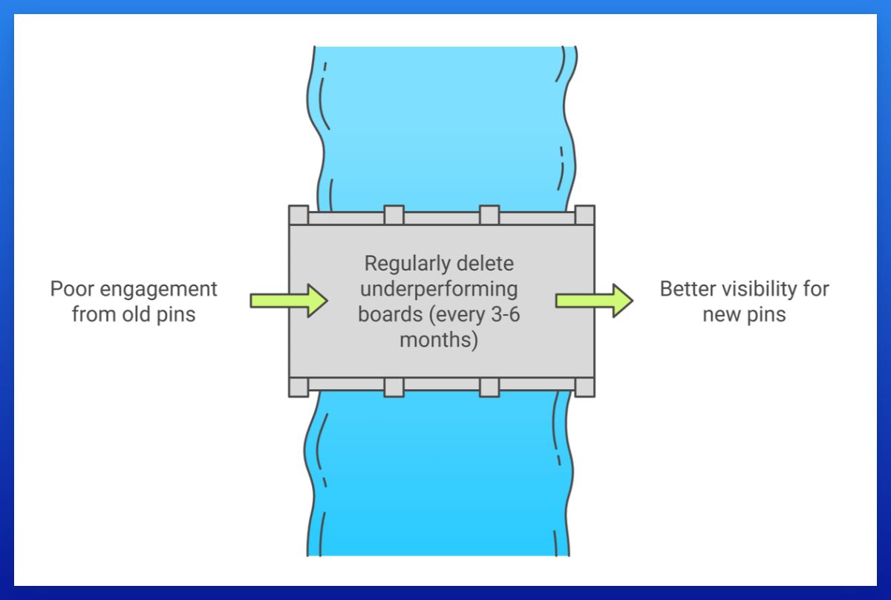
- Open your Pinterest Analytics > set Date Range to 30 Days > Export.
- Open the CSV and copy the data under "Top Boards".
- Delete all rows where the first number after the board link is over 100 (these are the impressions).
This way you only have all boards that can potentially be deleted.
- Match these boards with those in your account.
- The goal is to delete boards that have too many underperforming pins.

Before deleting, check:
- The ratio of pin count to impressions:
If you have a board with 100 pins and 1,000 impressions, that's not too bad, I'd keep it.
But if it's a board with 100 pins and only 10 impressions, most pins have zero impressions, and I'd delete it.
- If the board is older than three months:
Only delete underperforming boards that are older than 3 months!
- Remember, all pins within the board will be deleted automatically, so check carefully.

